|  |  |
| --- | --- |
|  | |
|  | **Hobby Store Online Platform** |
| High Level Requirements | |
| **Version 1.0.1** | |
| 9/30/2018 | |

**Project Identification**

|  |  |
| --- | --- |
| **Project:** | Sword & Board |
| **Prepared By:** | Jan Farun |
| **Document Version:** | 0.1.0 |
| **Published Date:** | 10 /02/2018 |

**Contributors**

*The following individuals contributed to this document.*

|  |  |
| --- | --- |
| **Name** | **Title** |
| Nolan Honey | *U/I, Back-end Developer* |
| Harry Archer | *U/I, Front-end Developer* |
| Saif Mustaf | *Back-end developer* |
| Jan Farun | *Database Developer, back-end Developer* |

**Distribution**

*This document is distributed to all the following people.*

|  |  |
| --- | --- |
| **Name** | **Title** |
| Anjana Shah | Professor |
|  |  |

**Referenced Documents**

*This document refers to the following materials*

|  |  |  |  |  |
| --- | --- | --- | --- | --- |
| **Version number** | **Title** | **Author** | **Date** | **Source / Location** |
| *1.0* | *High level requirements* | *Jan Farun* | Oct, 02 | Blackboard |
|  |  |  |  |  |
|  |  |  |  |  |
|  |  |  |  |  |

**Revision History**

|  |  |  |  |
| --- | --- | --- | --- |
| **Version Number** | **Revision Date** | **Summary of Changes** | **Modified by** |
| *1.0* | *Oct, 02* | *First version* | Jan Farun |
|  |  |  |  |
|  |  |  |  |

*[Note: It is recommended that drafts be numbered 0.1 to 0.9, and that the first approved version be numbered 1.0. Thereafter, new version numbers will depend upon changes: 1.01, 1.1, etc for minor updates, 2.0, 3.0 etc for major changes.]*

**TABLE OF CONTENTS**

***1.*** ***BUSINESS CONTEXT DIAGRAM 4***

***2.*** ***REQUIREMENTS SCOPE STATEMENTS 5***

***3.*** ***HIGH LEVEL BUSINESS REQUIREMENTS (HLR) TRACEABILITY 6***

***4.*** ***HIGH LEVEL BUSINESS REQUIREMENTS SIGN-OFF 7***

1. **Business Context Diagram**

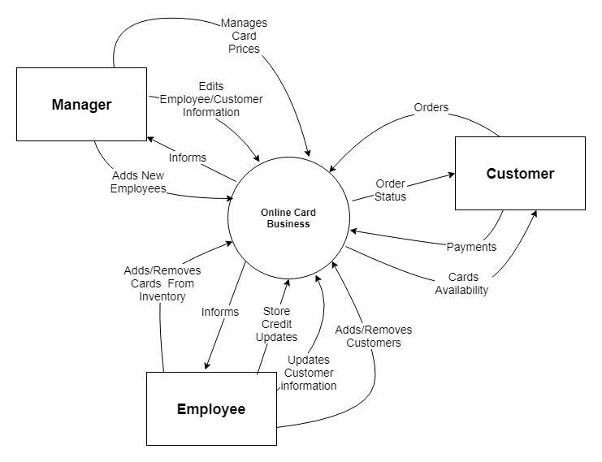

**2. Requirements Scope Statements**

|  |  |
| --- | --- |
| **Requirement Scope Area** | **Description** |
| Online Card Business | Area responsible for providing card information and access for clients and employees. |

|  |  |
| --- | --- |
| **External Entity** | **Description** |
| Manager | Sword and Board manger that can view, update or modify database, staff, and current client accounts. |
| Employee | Sword and board employee that can update, remove, add customer profiles and update their credit. |
| Customer | customer who can view, purchase cards, and add credit to their profile. |

|  |  |
| --- | --- |
| **Information Flows** | **Description** |
| Adds new employees | New Employees can be added/modified by manager. |
| Edits employee/customer information | Manager can edit employee/client profiles ie. name, age, role, credit. |
| Manages card prices | Database card prices that the manager can view or modify. |
| Informs | Employees, Clients, and Managers are given the ability to view the cards in the current database. |
| Orders | Any card that the customer purchases. |
| Order status | The status of the transaction made by a customer ie. pending transactions. |
| Cards availability | informs the client of the quantity of each card in inventory |
| Payments | Any payments a customer makes. |
| Add/removes cards from inventory | Cards are added or removed by either manager or employee. |
| Store credit updates | Customer’s store credit can be modified by employee. |
| Updates customer information | Employee may view, modify, delete any preferences or personal info on customer profile. |
| Adds/removes customers | Employee can add/remove clients in the database. |

**3. HIGH LEVEL BUSINESS REQUIREMENTS (HLR) TRACEABILITY**

|  |  |  |
| --- | --- | --- |
| **HLR#** | **Description** | **Priority**  **(H, M, L)** |
|  | **Managers and employees must be able to add new cards to store’s database using the referenced master database.** This process should be as simple as syncing the database. | H |
|  | **The manager must have master permissions in a system.** They should be able to edit the accounts of both customers and employees while also having the capabilities of performing the same functions as a regular employee. | H |
|  | **Customers can sign up for an account** on the website. They will be able to see their store credit balance and order history. Additionally they will be able to change their information that was previously submitted. | M |
| HLR04 | **Managers can add new employee to a system.** Managers have the authority to upgrade a basic account into an employee account. This allows employees to help customers spend their store credit and change the customers information. | H |
| HLR05 | **Customers must be able to browse store stock.** The stores stock must be stored online in an accessible way to customers. This will be an optional system as some implementers may not want to share their stock. | L |
| HLR06 | **Customers can view their store credit.** Store credit will be stored in a dedicated database. Employees will be able to add and subtract credit. Credit may be spent in store and potentially online depending on the implementation. | M |
| HLR07 | **Manager needs be able to edit employee information.** Should an employee no longer be employed their employee privileges must also be removed. Managers must also be able to monitor changes that employees make to people's store credit pages as well. | L |
| HLR08 | **Employee needs to modify customer information.** Employees should be able to edit customers names, phone numbers, etc. They should also be able to edit their store credit when they make a transaction. Additionally employees should be able to create new customer accounts when requested. | L |
| HLR09 | **Customer can reset password.** Should a customer lose/forget their password they should be able to reset their password using their associated email. Additionally employees should be able to do this for them if they come in to the store. | M |

**4. High Level Business Requirements Sign-Off**

*The undersigned acknowledge their agreement with the contents of Version <*0.1*> of the* High-Level *Requirements document for <Sword & Board>*.

*Following approval of this document, requirements changes will be governed by the project’s change management process, including impact analysis and appropriate reviews and approvals, under the general control of the Project Plan and according to company policy. Approved Change Request Documents, if present, will be attached to this Requirements Document as updates.*

|  |  |  |
| --- | --- | --- |
| **Name** | **Project Role and**  **Functional Area** | **Date Signed** |
| Nolan Honey | Developer/Stakeholder | 02-10-18 |
| Harry Archer | UI / Front-End Developer | 03-10-18 |
| Jan Farun | Database Developer /Back-end | 03-10-18 |
| Saif Mustaf | Full-stack Developer | 03-10-18 |

*\* Note: physical signatures are not required. Email approvals are acceptable and should be appended to project documents.*